Tyus/Day 3rd Grade- Math/Science Teacher Schedule
Instructional Delivery Model | Time | Activity
(LIVE) | SEL (Check-In)  7:45 - 8:00 | SEL (Check-In)  (15 min,/Synchronous)
(LIVE | Mathematics  8:00 - 8:30 | Math (30 min./Synchronous-LIVE)
 | Mathematics  8:30- 9:10 | Math  (40 min./Asynchronous/ Small Group/ Independent Work)
 | Mathematics  9:10 – 9:30 | Math  20 min/Small Group
(LIVE) | Exploratory Classes  9:30-10:10 | Exploratory  40 min.
BREAK
10:10-10:20
(LIVE) | Science  10:20- 10:50 | Science (25 min/Synchronous-LIVE)
 | Science  10:50- 11:00 | Science (15 min/Asynchronous-Independent Work)
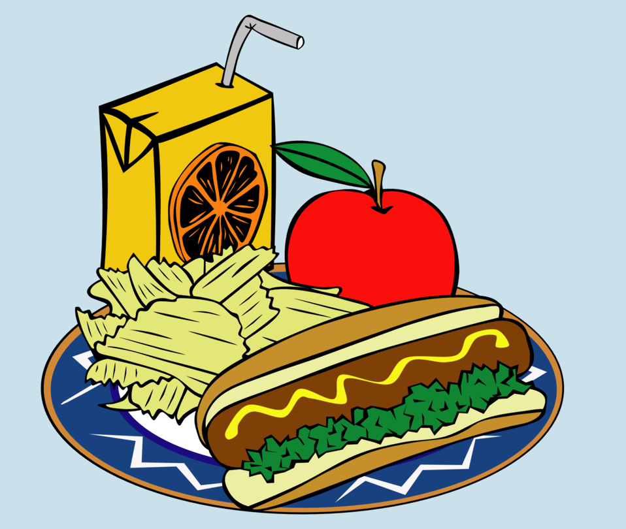 | Lunch 11:00 - 11:45 | LUNCH -45 min.
 | Math  11:45- 12:15 | Math (30 min/Synchronous-LIVE)
Break
12:15-12:25
 | Math  12:25-1:00 | Math Asynchronous  (40 min/Asynchronous- Independent/Small Group/Work)
BREAK
1:00- 1:10
 | Science  1:10-1:30 | Math Small Group  20 min
 | Science  1:30 – 2:00 | Science (20 min/Synchronous-LIVE)
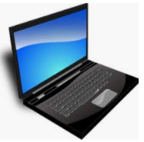 | Science  2:00-2:20 | Science (20 min/Asynchronous-Independent Work)

